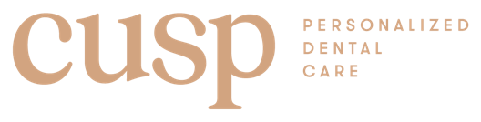

POSTOPERATIVE SINUS PRECAUTIONS

In surgeries involving the Maxillary sinus, positive or negative pressures are to be avoided during the healing period. Please follow these precautions until otherwise notified:

1. Do not blow your nose.

2. Do not use a straw.

3. Do not smoke.

4. Do not play wind instruments.

5. If you sneeze, do so with your mouth open.

6. Do not use a sauna or steam room for three months.

I have read and understand the instructions given to me. I have had a chance to ask questions regarding these instructions and they have been answered.

Patient Signature: _________________________
Date: ___________

